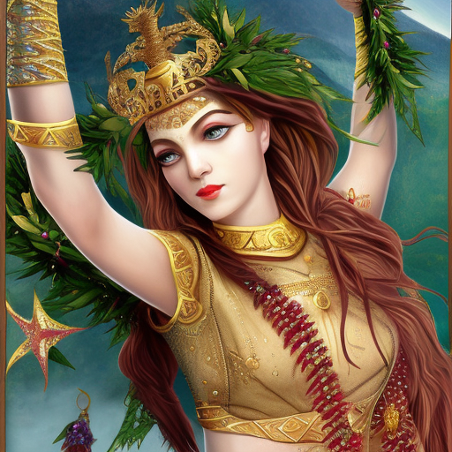
OUR LADY OF TIBET’S GRAY GLORY

Crowns of Thorns become Laurel Wreaths
Ratnasambhava’s jewel shimmers with courageous bliss
Mara’s maidens dance as redeemed dakinis
Streams of Her Secret Righteousness flow
Jagged mountains like magi justly ruling aeons
Stars of the Sea beaming like White Stones
Four queens the warrior’s walls
Drawn within, weaving ever toward the Golden Core
Tender heart reactions ever soothing Her Effervescent Resplendence
She draws the bridges of Chinvat unto Herself

